**MyPortfolio Website**

**Light Theme :**

1. **Home Page**

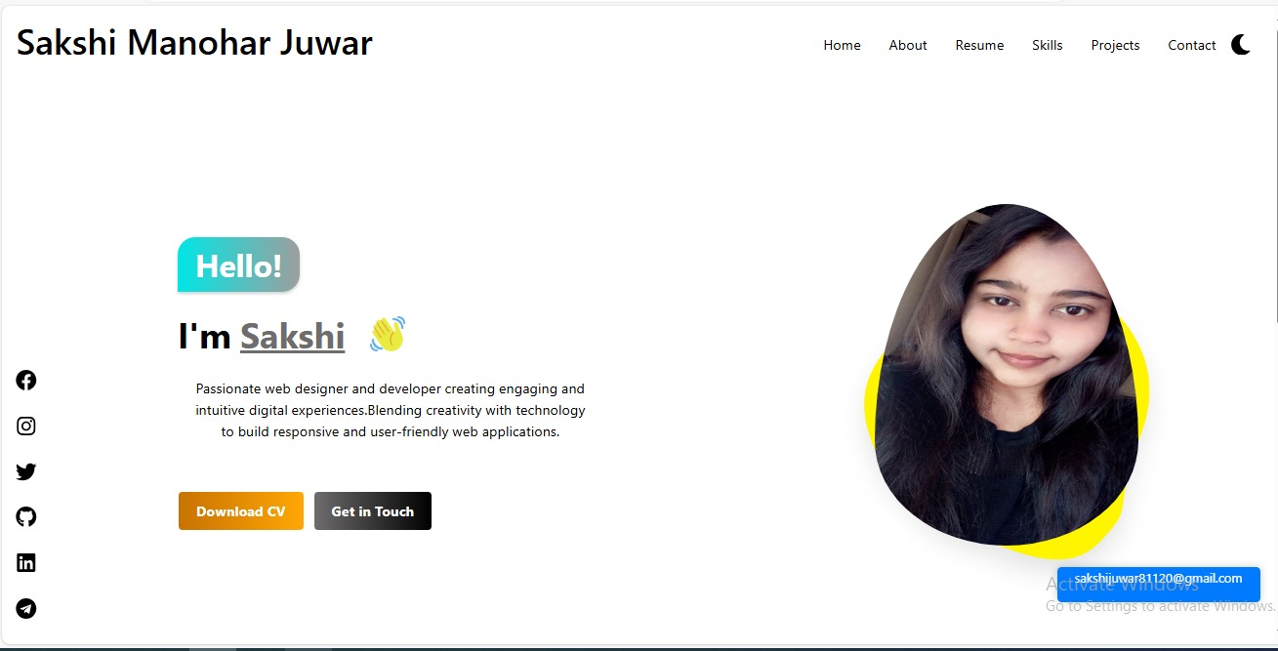

1. **About Page**

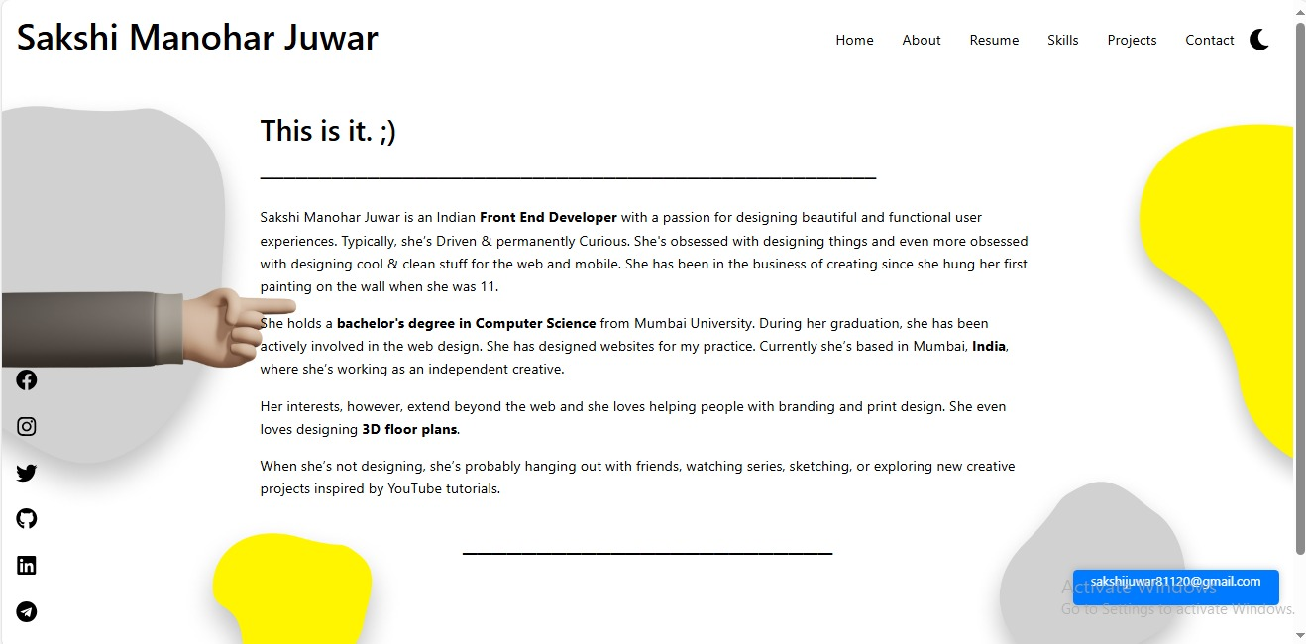

1. **Contact Page**

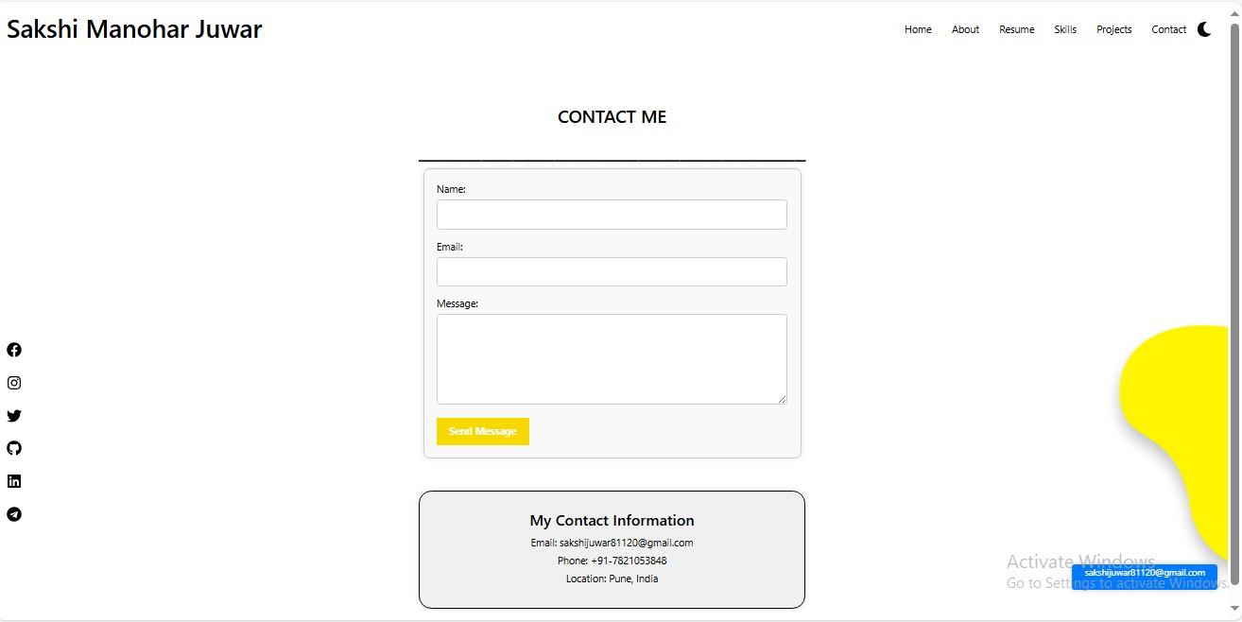

1. **Resume Page**

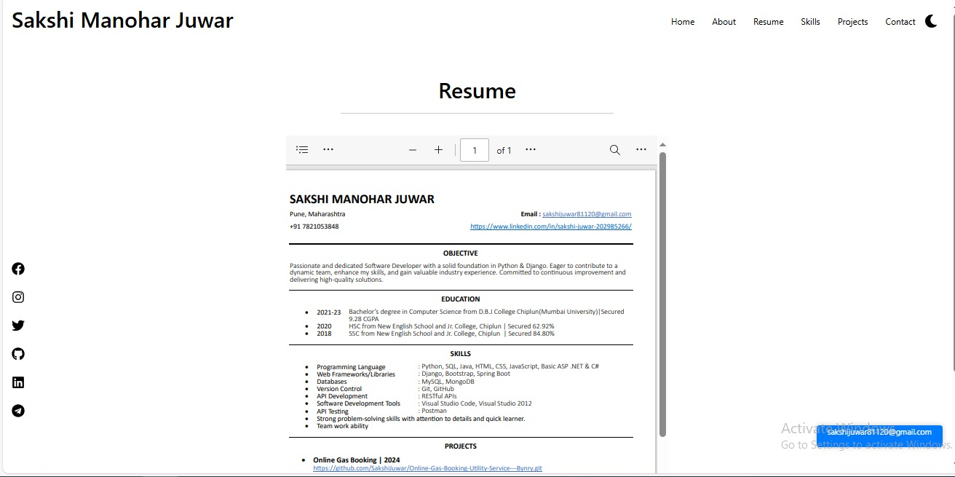

1. **Skills Page**

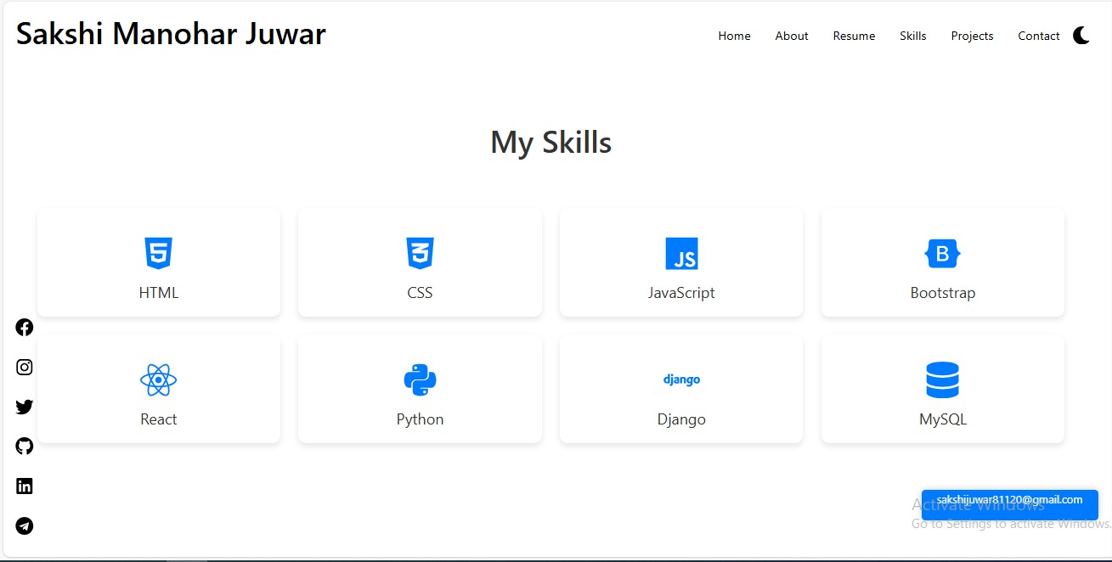

1. **Project Page**

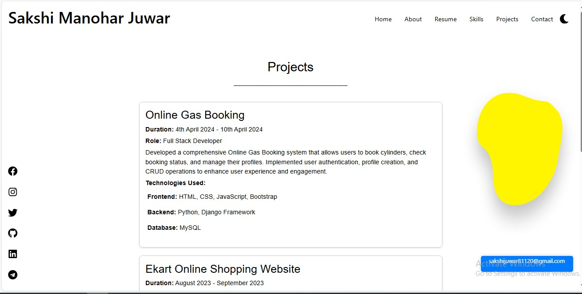

**Dark Theme :**

1. **Home Page**

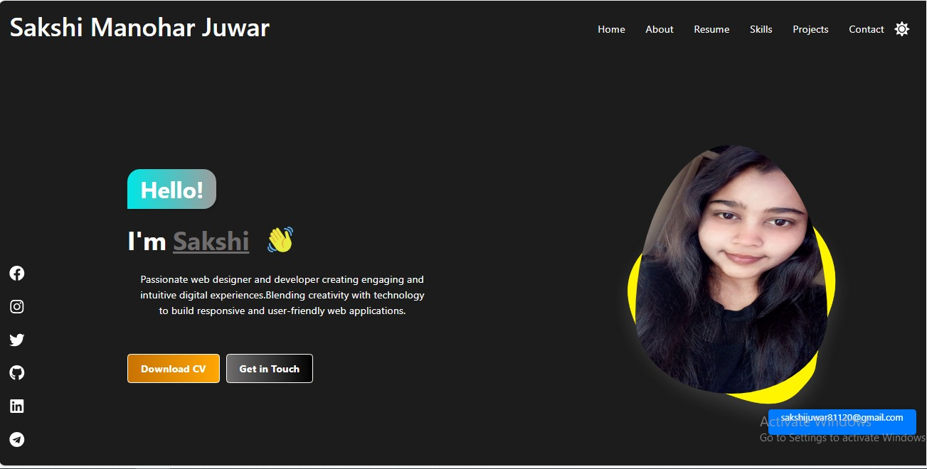

1. **About Page**

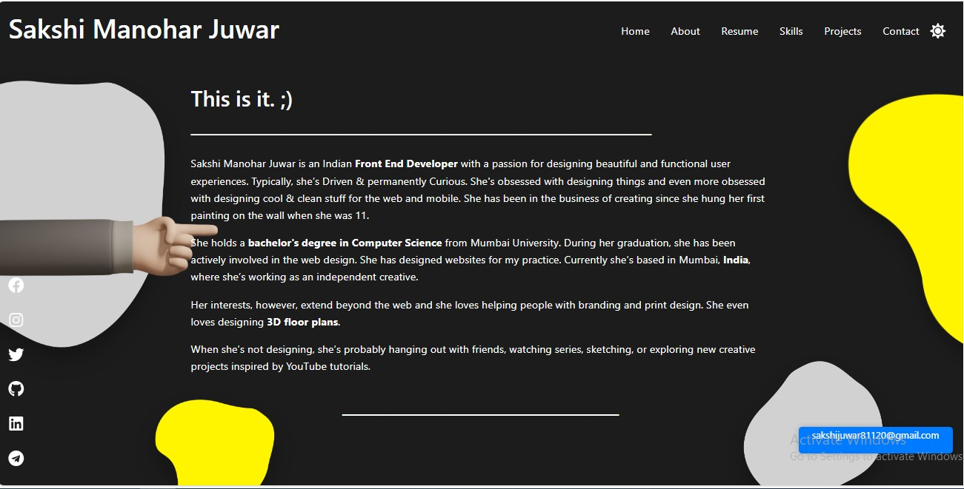

1. **Contact Page**

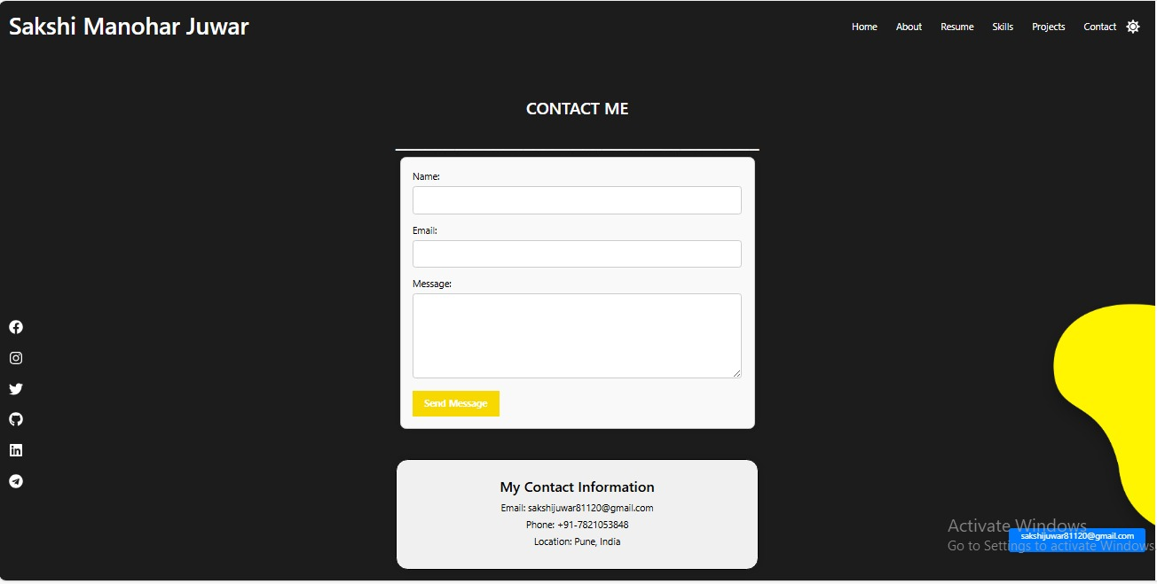

1. **Resume Page**

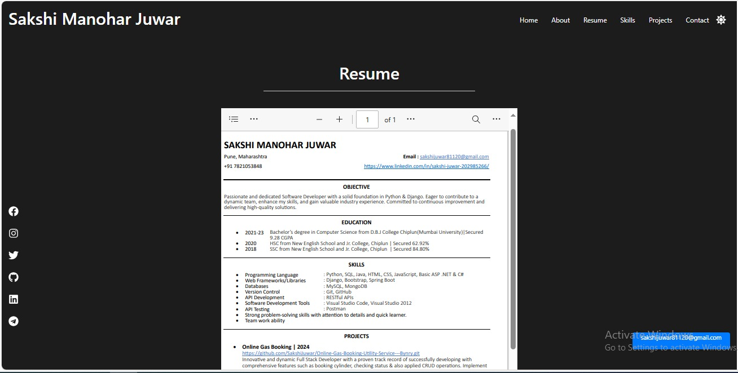

1. **Skills Page**

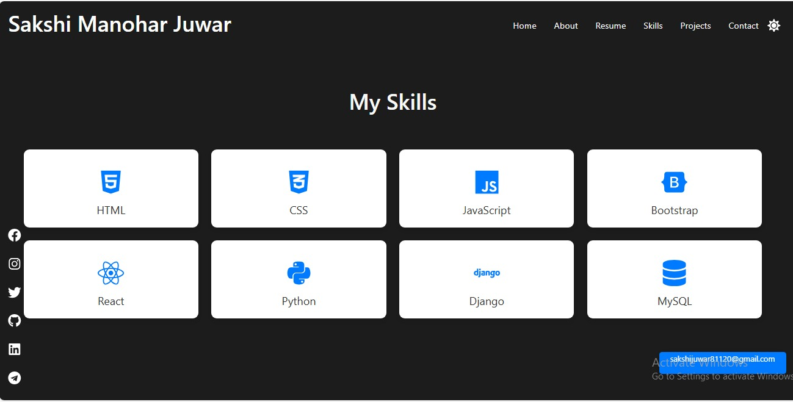

1. **Project Page**

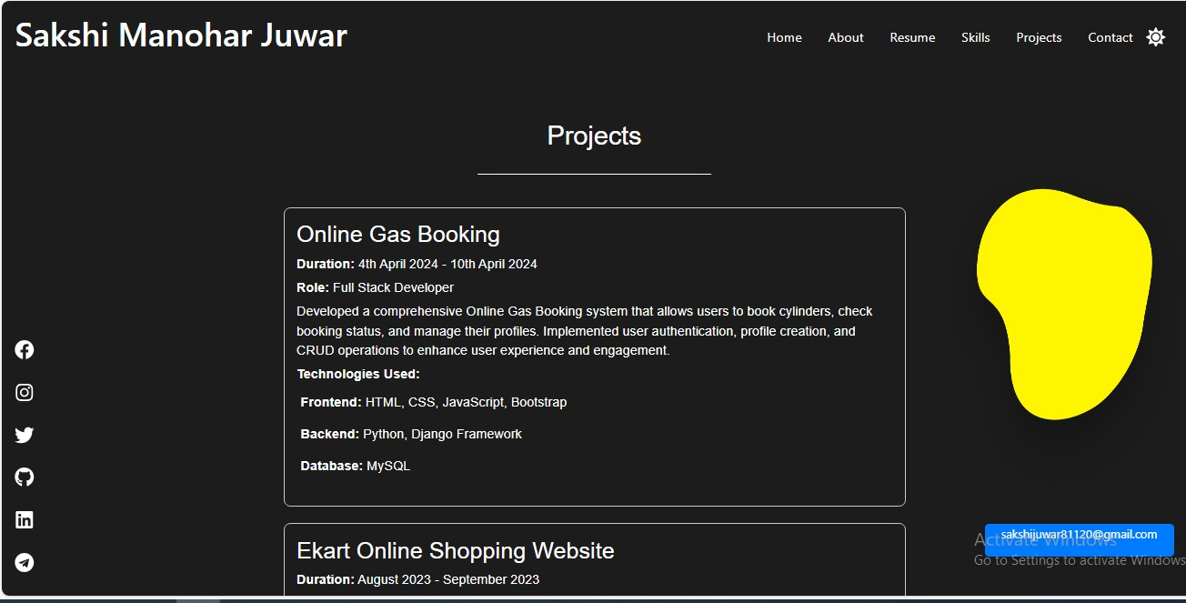

**Portfolio Website Working & Description**

* This is my personal portfolio website built using React, HTML, CSS, JavaScript, and Bootstrap. The website supports both light and dark themes and has several interactive features.
* Light and Dark Theme :

Switch between light and dark themes using the moon and sun icons.

* Responsive Design :

The website is fully responsive and works well on all devices.

* Download CV :

Click the "Download CV" button on the home section to download my resume.

* Contact Form :

Fill in all inputs in the contact form and enter a valid email. On submitting, the form sends a message to my email.

* Interactive Navigation : The website includes the following sections:
* Home :

Introduction of me

download CV button -

* About : Information about me, my background and experience.
* Contact : Form to get in touch with me.
* Resume : My all educational information.
* Skills : A display of my skills.
* Projects : Showcases of my projects.
* **Installation of Project :**

To run the project locally:

1. Clone the repository:

In VS Code : Clone Repository (copy below link & paste it into clone repository )

git clone <https://github.com/your-username/portfolio-website.git>

cmd - npm install

cmd - npm start